**12 Premium Batik Styles Vol 2**

design by **Agustin08**

**First of All, Thankyou for purchasing my item on GraphicRiver**

**GUIDE**

# 1. Extract the ZIP file

# 2. There is 2 types file per format : ASL and readme PDF

# 3. you can Start use, just one click the layers

1. to use the style, type the text you want.

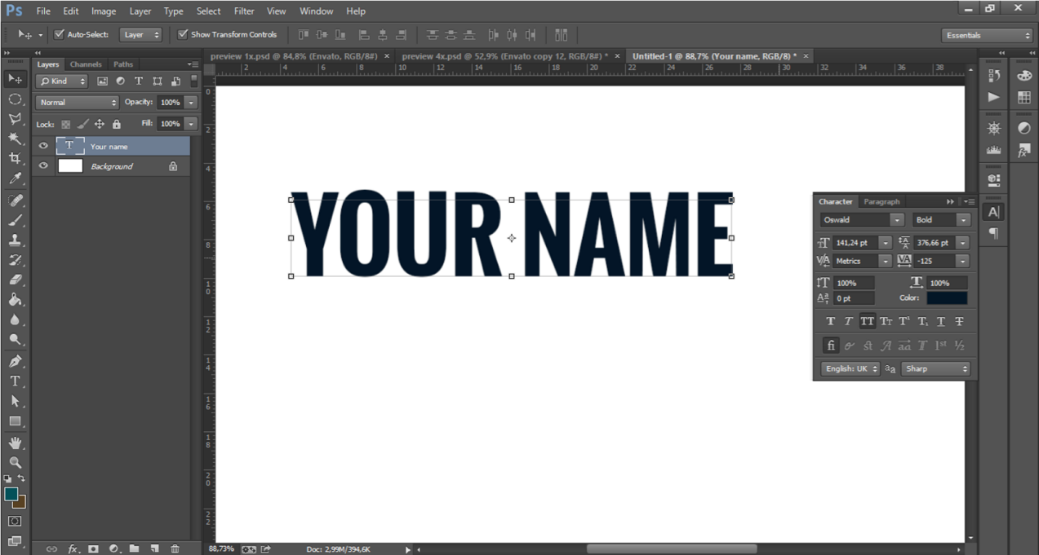

1. use gray or white.

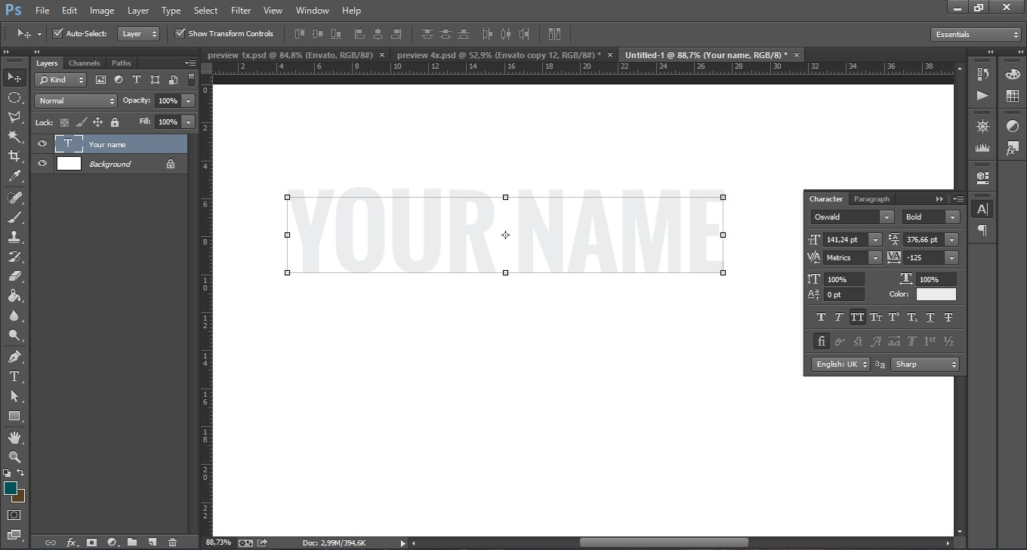

# c. click menu “windows → Styles”

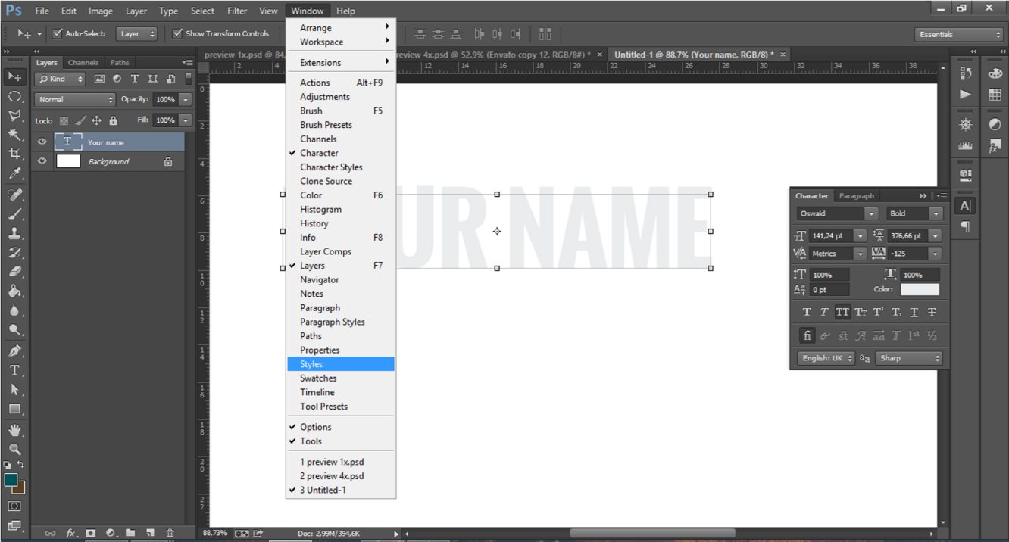

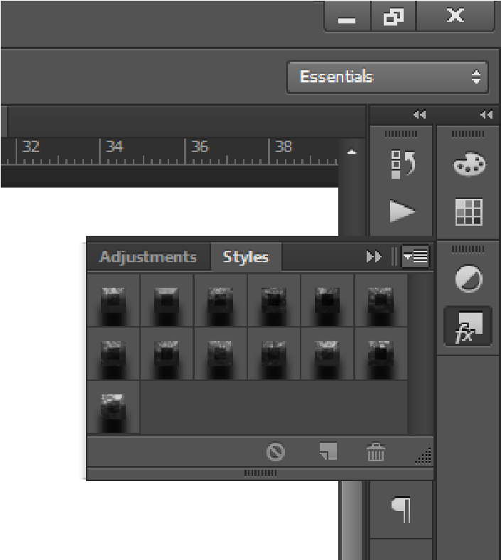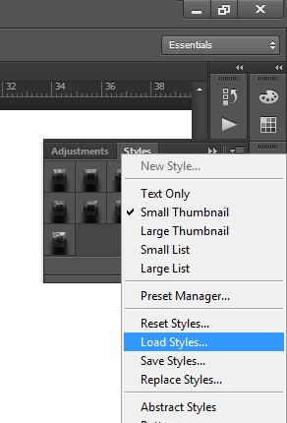

d.

Instal Style..

Click

Choose the style

that will be

used

.

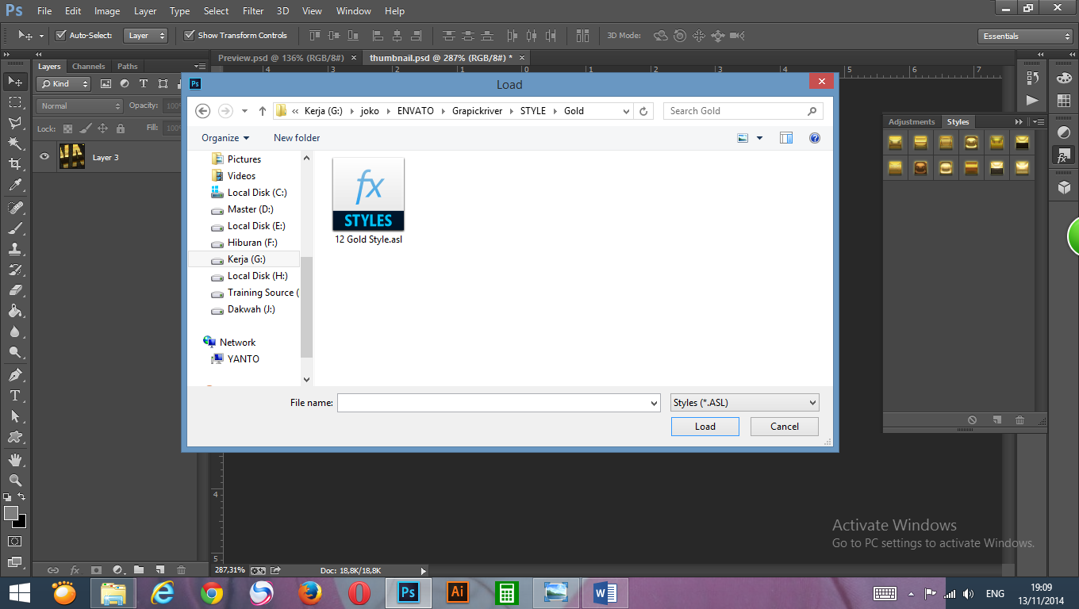

# e. Just one click..

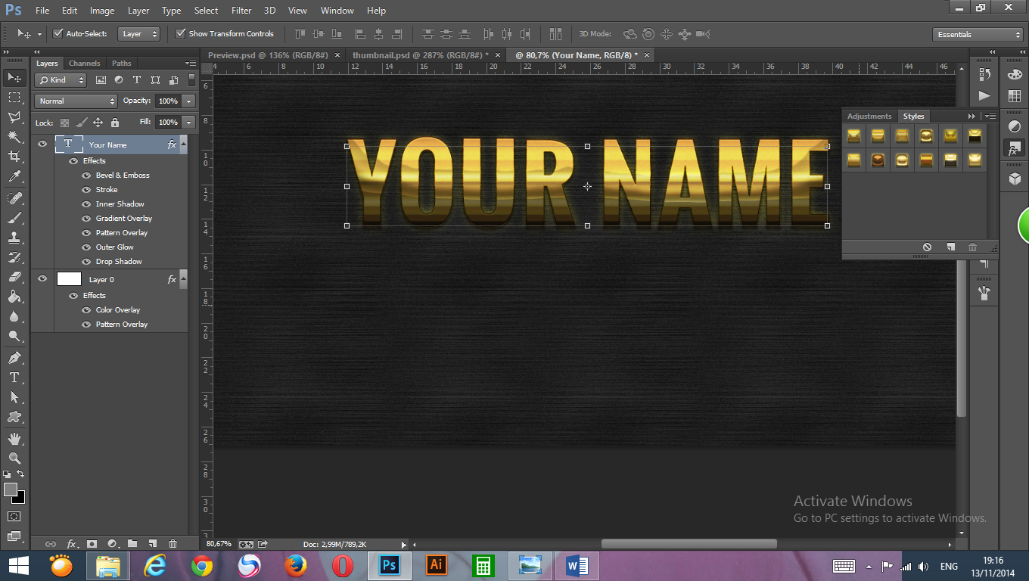

# g. save : click menu file → save as… → PNG or JPG

# Don't forget to give this 5 star rating..! :) enjoy!

# **Agustin08**