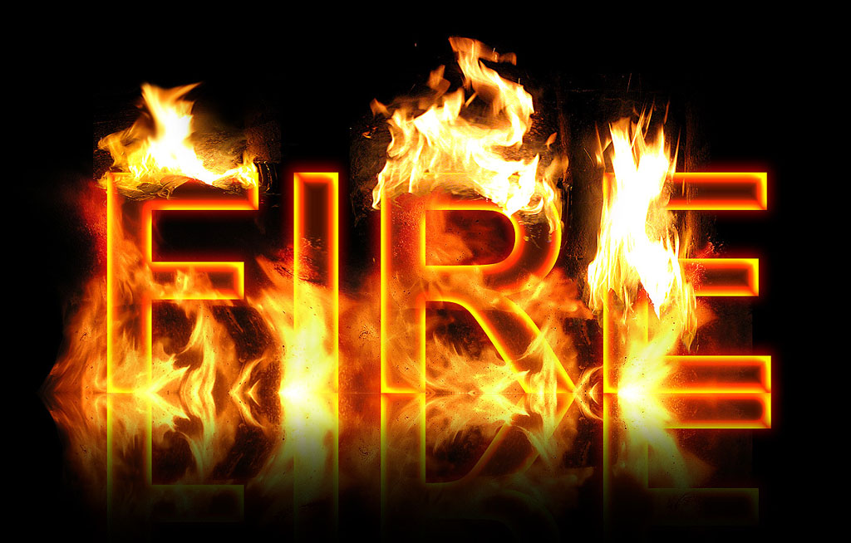
Real Fire Text Creator is PSD template that allows very easily to create a realistic fire effect on texts.
Features
- Ready-made template with editable text.
- 10 transparent fire effects, ready to be applied and overlapped on text.
- Reflection surface effect.
- 2000x1500 px resolution image.
- Customizable background.
Instruction Guide
File structure:
Inside the PSD file there are 10 elements (fire effects), 5 of them on a single layer (suitable for higher positioning), and 5 of them grouped together with their reflection effect (suitable for lower positioning, close to the reflection surface). The text itself is in a group too, that includes the reflection effect. All of these items are put together into a single group called Elements with a layer mask. This mask has the function of creating a fade-off effect for all the reflections in the scene. Separately, there is the background with a gradient effect.
Usage guide:
Replace the default text and it’s reflection text with whatever text you want. If it’s bigger in width than the PSD file, expand the width of the canvas size (the gradient blending effect on the background will mantain the look). Now, you are free to play with the fire elements. Move them, copy them, rotate them, overlap them, experiment until you get the effect you want.
Enjoy!

