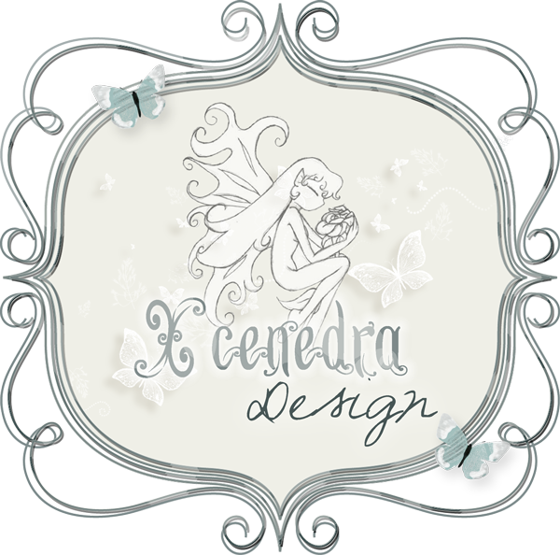
General Term Of Use For CU
Blog: http://xcenedradesigns.wordpress.com/blog/
Store: http://digital-crea.fr/shop/
Contact: xcenedradesigns@gmail.com

THANK YOU FOR BUYING

This product was created by Xcenedra Designs. The product is for Commercial use, but the product itself can not be resold - only product created USING THIS PRODUCT can be sold commercially.
Do not make kits or sets containing only items created using my items.You can do make template with this items.
Do not use any images for obscene, defamatory, or immoral works or any other purpose which is prohibited by law.
Feel free to modify images (size, color, etc.) as necessary.
Don't make commercial use products with my cu kits.

YOU MAY:
-Use these products in your photography, scrapbooking and/or design business to the extent listed below:
-Create custom greeting cards, candy wrappers, layouts, invitations and other printed materials for your customers provided that they are finished pieces. This means that you may sell items that are printed but you may not sell a download or cd of any kind.
-You may use products incorporated into your designs to create scrapkits but may not be resold as a stand-alone product. You may not make brushes,rub-ons, or include in a kit for redistribution.
-You may use the graphics in your web design projects providing that proper credit is given on the website
All website design must be for family friendly websites only. No indecent websites will be tolerated.
We reserve the right to request this list at any time.

YOU MAY NOT:
-You may not offer as a freebie and not allowed to share for free .
-Claim these graphics as your own either in their original state, or in an altered state.
-Offer downloads of the kits/graphics in any way shape or form. Distribute these graphics in any format except for the uses defined above.
-Unless noted for commercial use, you may not make into an alpha product
-Print or have printed any of the original graphics, papers or kit pieces to sell in stores on websites or on ebay.
You cannot buy a kit and print pieces or papers from it and sell those in stores or online shops.
-Share these files with friends, family, etc. Please feel free to direct them to the store where you purchased your product.
-Sell these graphics through any means in their purchased format.

