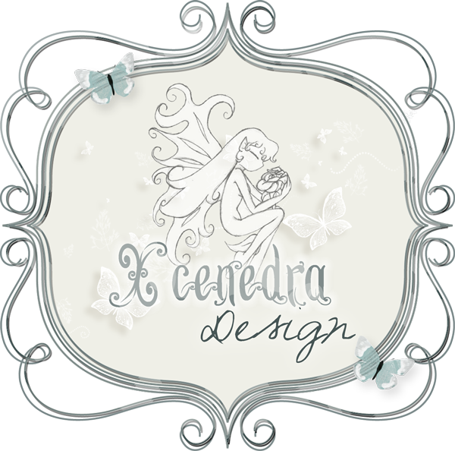
General Term Of Use For Personal Use/ S4H
Blog: http://xcenedradesigns.wordpress.com/
Store: http://digital-crea.fr/shop/
Contact: xcenedradesigns@gmail.com

THANK YOU FOR BUYING “Belle d’automne”
SPECIAL THANKS TO : agnesingap, ange, andjelina designs, yalana, cucciola, delmik, feli, joeg, lalig, laitha, manue, mariR, marta designs, mystique, olga unger, pinklotty, sekada, starlight, tiramisu, valentina creations, wiktoria.

These graphics have been made by Xcenedra Design The items are designed for your personal use and may not be used in any commercial way.
- You may not offer them in any other graphics collection, on a website, or individually, either for sale or free, create a competing product from them to sell or redistribute, and are not allowed to trade or share this kit.
-You may not add to or distort, alter or re-colour any graphic and claim them as your own.
-You may not make any graphics into tubes or brushes and redistribute them in any way
-YOU MAY NOT use these graphics to make freebies or quickpages for download without my permission.
- Do not use these images for obscene, defamatory, or immoral works or for any other purpose that is prohibited by law.
- Feel freel to alter these images to fit your scrapbooking needs, including resizing, recoloring and cropping as long as credit is given to the designer.
- If you use these graphics in a layout submitted to an online gallery, magazine or other publication you must give credit to Xcenedra Design.

