How to Use Abstract Grunge Photoshop Action
Hello, thank you for buying this action.
This action has been created and optimized for use on Photoshop CS5 and above .
Use the RGB Mode and 8 Bits color. To check these settings, go to Image->Mode and
check the “RGB color” and “8 Bits/Channel”.
Make sure you are using the English version of Photoshop
In layer “Layers Panel Options”, check “Add ‘Copy’ to Copied Layers and Groups”. To check these settings, click on the top right corner of the layer palette, go to “Layers Panel Options” and
check “Add ‘Copy’ to Copied Layers and Groups”.
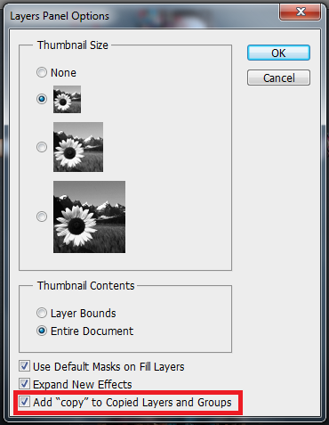
For the best results, it is recommended to use high resolution photos in the range
of 2500px – 3500px. The detail and clarity is affected with respect to quality of the image.

How to Use The Action:

Step-1
Open the image you want to work with and make sure the image as Background layer..
If the image is not background image, select the image layer and go to Layer >> New >> Layer From Background.
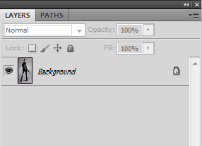

Step-2
Create a new layer just above the background layer and rename it as “brush” (all small letters).
In the new layer, paint over the area you want to apply the action.
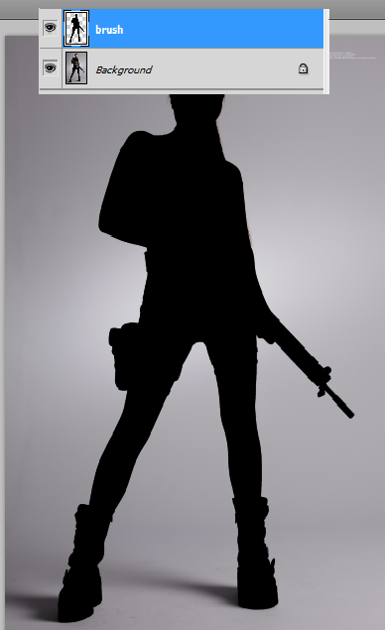

Step-3
Load Brushes:
Load the brush set “Abstract Grunge”
To load the brush set, go to Window>>Brush presets
In the preset panel, click on the top right corner of the panel and select “Load Brushes” and choose the “Abstract Grunge” brush set.
Load Actions:
Load “Abstract Grunge “ action.
To load the action, go to Window>>Actions.
In the Action panel, click on the top right corner of the panel and select “Load Actions” and choose the ‘Abstract Grunge’ action file.

Step-4
Select the “brush” layer.
There are 2 actions in the set.
Select one of the “Abstract Grunge” actions and click on “play selection”.
It may take one or two minutes to complete the action.
That’s it, you get the final result.
Mask/Unmask: In “Subject” folder, there is a layer named “unmask face” to unmask effect on the face.
There are three other layers in the same folder named as
“Unmask areas u want 1”
“Unmask areas u want 2”
“Unmask areas u want 3” to mask or unmask the effects as per your requirement.....

Note: If you have any problem with the action, please contact me by: tryphotoshop19@gmail.com

